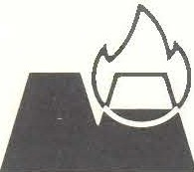

**MINTEK**

**COMMUNICATON**

**No. C 1156M**

**Chlorination of Germanium and Other**

**Metals in the Alloy Obtained by**

**Reduction of Tsumeb Slag**

**by**

**AW Fowles**

**CONFIDENTIAL**

**17th February 1989**

**COUNCIL FOR MINERAL TECHNOLOGY**

**200 Hans Strijdom Drive RANDBURG**

**South Africa**

**MINERAL AND PROCESS CHEMISTRY DIVISION**

**Chlorination of Germanium and Other Metals in the Alloy Obtained by Reduction of Tsumeb- Slag**

**17th February 1989**

DIRECTOR OF DIVISION: R L Paul

ASSISTANT-DIRECTOR: CA Fleming

INVESTIGATOR: AW Fowles

PROJECT NO. 303871A

THRUST NO. 028

DATE: 17th February, J989

**SYNOPSIS**

High temperature chlorination was used to recover germanium from an iron-germanium alloy, the germanium comprising about 0,3 per cent of the alloy, with small amounts of molybdenum, arsenic and copper also present. The metal chlorides were volatilized and separated by condensation, with the germanium tetrachloride being recovered in water. High chlorination and recovery efficiencies were obtained, showing that this process is technically feasible on a small scale.

**CONTENTS**

1. INTRODUCTION

2. LITERATURE SURVEY

3. IBERMODYNAMICS

4. EXPERIMENTAL

4.1 Materials

4.2 Apparatus and Procedure

4.3 Chemical Analyses

5. RESULTS AND DISCUSSION

5.1 Separation of FeCl3 and GeC14

5.2 Extent of Chlorination

5.2.1 Effect of Time

5.2.2 Effect of Temperature

5.2.3 Effect of Sample Quantity and Particle Size

5.2.4 Effect of Gas Flowrates

5.3 Recovery of GeCI4

5.3.1 Saturation Limit

5.3.2 Water Trap Variations

5.3.3 Contaminants

5.3.4 Chloride Distribution Through System

5.4 Chlorination of Tsumeb slag fume

5.4.1 Effect of temperature

5.4.2 Effect of time

5.4.3 GeC14 recovery and contaminants

5.4.4. Roasted fume

6. CONCLUSIONS

7. REFERENCES APPENDIX

**Chlorination of Germanium**

**INTRODUCTION**

Goldfields and Tsumeb Corporation Limited (TCL) are keen to develop a process for the recovery of zinc, germanium and lead from their smelter slags, with the emphasis being placed on germanium owing to its economic value. At present, more than 2 million tons of slag are stockpiled at TCL, with their blast furnace producing another 105 tons per year. A number of sponsored projects with the objective of recovering Zn, Pb and Ge are currently underway in the Pyrometallurgy and Mineral and Process Chemistry Divisions. However, some problems have been experienced with the more conventional fuming/hydrometallurgical approach, and an alternative, simpler, process has been sought.

The envisaged process is to reduce the Tsumeb slag, containing Ge, Zn, Fe, Pb and other metal oxides, as shown in Table 1, at a temperature above 1 530°C, so as to collect the Ge in a molten iron metal phase. This would then be tapped from the furnace, granulated and chlorinated. The volatile GeCl4 and FeCl3 thus produced separate on condensation, due to their different sublimation temperatures, with the Ge being recovered.

The aim of the small-scale work presented here is to determine whether the chlorination process is technically feasible, and to find the best conditions for recovering the Ge and separating it from Fe.

**Table 1**

**Components of Tsumeb Slag**

|  |  |  |  |  |  |  |  |  |  |  |  |  |
| --- | --- | --- | --- | --- | --- | --- | --- | --- | --- | --- | --- | --- |
| Metal | Fe | Ca | Si | Mg | Al | Zn | Pb | Cu | Mo | As | Ga | Ge |
| %  (by mass) | 16 | 17 | 12 | 4 | 2 | 11 | 2.5 | 0.4 | 0.2 | 0.4 | 0.02 | 0.04 |

**2.LITERATURE SURVEY**

A large amount of research has been carried out on the chlorination of iron. With iron being the major constituent of the alloy to be chlorinated, much of the information is relevant. However, there is not much available on the chlorination of Germanium.

The following mechanism for the chlorination of iron appears to be accepted by most researchers in this field.

Fe (s) + Cl2 (g) **4** FeC12 (s) (1)

2FeC12 (s) + Cl2 (g) 4 Fe2Cl6 (g) (2)

Reaction (2) is followed by diffusion of the ferric chloride from the surface into the bulk gas phase.

Foroulis<1•2> states that FeC12 is a solid throughout the range 267 - 567°C investigated and forms a film on the metal surface that influences the rate of the chlorination reaction. The rate has a linear dependence on the chlorine partial pressure. The rate-determining step in the overall reaction is the rate of mass transport of chlorine gas or Fe2Cl6 gas to and from the FeC12 (s) surface layer - gas interface, respectively, depending on the experimental conditions. The formation and growth of the FeC12 film, which causes an initial increase in sample mass, occurs until a steady-state thickness is attained. This rate of growth is controlled by diffusion through the layer and is therefore inversely proportional to its thickness. Fruehan<3> found that the rates of diffusion of. Chlorine and Fe206 through the gas phase boundary layer affect the steady-state layer thickness, and the time to reach.

steady-state, but do not affect the steady-state rate of Fe2Cl6 formation. He also

found that above 530°C the rate is relatively independent of temperature, but dependent a gas flow. Between 350°C and 530°C the rate is controlled by the surface reaction and transport of chlorine. Kumar et al<4), however, found that gas.

Flowrates in the range 400-1000 ml/min have only a slight effect on reaction rate, 2

and that the rate is hardly sensitive to temperature.

Landsberg et al<5) state that the rate of chlorination of Germanium is directly proportional to the chlorine concentration, increases with temperature, and is diffusion controlled. The following mechanism is postulated:

Ge + CI2 -t GeC12

GeC12 + Cl2 GeCI4

where GeC14 is the condensed product. However, it is uncertain whether complete.

Chlorination occurs on the metal surface, or if the subchloride vaporizes and reacts with additional chlorine. A large-scale procedure for chlorinating germaniferous material (Ge .:::_ 60 per cent by weight) was devised by Harner et a!C6). It involved the reduction of the material at high temperature to yield metallic germanium, which was then chlorinated at 300° - 500°C using chlorine. The GeC14 produced was liquified in a water-cooled condenser.

3. **THERMODYNAMICS**

Gibbs free energies of reaction were calculated for the chlorination of the major metals present in the alloy (reduced Tsumeb slag). Their relative proportions and physical properties are given in Table 2, together with the possible chloride complexes. Calculations were made for 1 mole of metal reacting with chlorine gas to yield the appropriate chloride, within a temperature range of 100°C - 1 000°C. Chlorination at higher temperatures is limited by the refractories available.

Figures 1 and 2 show the relative stability of the various metal chloride species that could be expected to form on chlorination of the alloy. It can be seen that Ge chlorinates more easily than any of the other metals, to form GeCI4• FeC12 and

FeCI3 (as a solid, dimer or gas) are almost equally stable. FeC13 exists as a solid up to about 400°C, above which temperature the gaseous dimer is dominant. Above

750°C it exists mainly as the gaseous monomer.

**Table 2**

**Main Components of the Alloys Produced in the Pyromctallurgy Division. their Chlorides and their Physical properties.**

|  |  |  |  |  |
| --- | --- | --- | --- | --- |
| Metal | Melting point  1 0C | Boiling point | % (By mass) | |
| Alloy 7/B | Alloy 21 |
| Fe | 1535 | 2750 | 81.4 | 88.4 |
| Cu | 1083 | 2567 | 2.8 | 3.5 |
| Mo | 2610 | 5560 | 2.2 | 2.2 |
| As | - | 613 | 3.7 | 3.4 |
| Ge | 937 | 2830 | 0.31 | 0.40 |
| FeCI (g) | - | - |  |  |
|  | |
| FeC12 | 677 | 1024 |
| FeC13 | 304 | 332 |
| CuCl | 430 | 1490 |
| CuCI2 | 620 | 993 |
| MoC13 | - | - |
| MoC14 | - | - |
| MoC15 | 194 | 268 |
| MoC16 (g: | - | - |
| AsC13 | -8.5 | 130 |
| GeCl (g) | - | - |
| GeC12 (g) | - | - |
| GeC13 (g) | - | - |
| GeC14 | -50 | 84· |

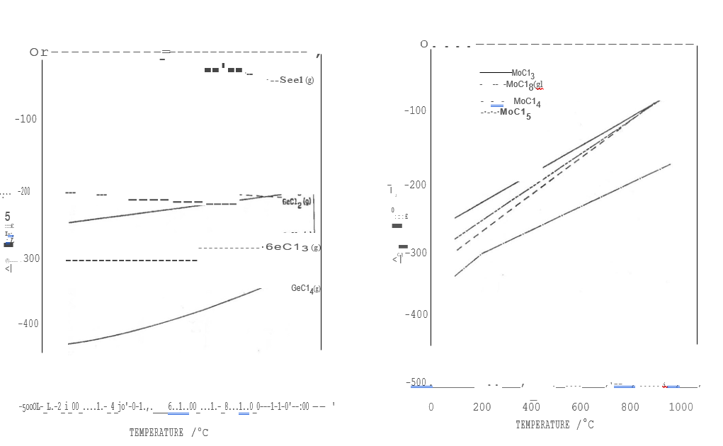

Fig.1 - The stability, as a function of temperature, of chloride species expected to form upon chlorination of lhc alloy.

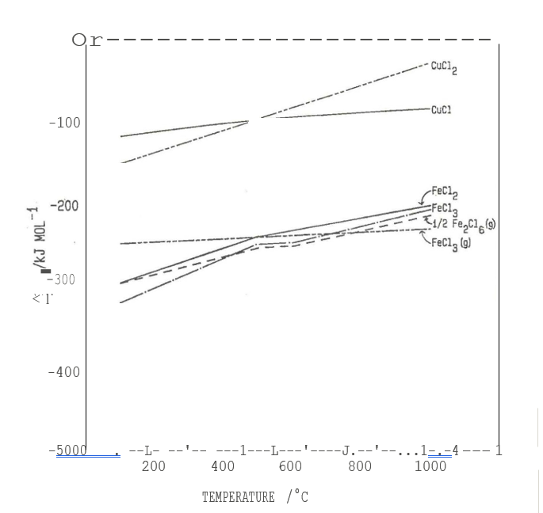

Fig.2 - The stability, as a function of temperature, of chloride species expected to form.

upon chlorination of the alloy.

**4. EXPERIMENTAL**

**4.1 Materials**

Pure Fe and Ge powders, alloy 7/B and alloy 21 (particle size < 315 um) were chlorinated. Industrial-grade chlorine was used as the chlorinating agent, and spectrographic-grade argon as the carrier gas. Distilled and deionized water was used to collect the GeC14.

**4.2 Apparatus and Procedure**

The chlorination’s were carried out using a packed silica tube of internal diameter 3,6 cm and length 76 cm, with the sample supported between clean dried silica wool. Kaowool and silica wool plugs were placed near the end of the tube. The tube was placed in a Kanthal-wound, resistively heated, 1,5 kW tube furnace. During most chlorination’s, heating tape was wrapped around the tube beyond the furnace to regulate the cooling zone. The furnace and heating tape temperatures were regulated by a Pye Ether Transitrol controller; temperatures were measured using Pt-Pt 13 per cent Rh (R-type) and NiCr-NiAl (K-type) thermocouples. Gas flowrates were measured using conventional rotameters. Round-bottom flasks and Dreschell bottles (containing 100- and 200-ml water respectively) were used as traps.

The system was purged at room temperature with argon to remove oxygen and then heated to the desired temperature. At this point chlorine was allowed to enter and the heating tape was maintained at: r 150°C. After reaction, the furnace and chlorine flow were turned off, but the argon was left flowing until the system had cooled to room temperature, and the chlorine had been flushed out. The apparatus and temperature profiles of the furnace

are illustrated in Figures 3 and 4. Details of the experimental conditions.

Fig.3 - Chlorination apparatus

Fig. 4 - Temperature profile of furnace used in table 1 of the Appendix.

**4.3 Chemical Analyses**

All analyses of solutions and solid material were carried out by the Analytical Science Division of Mintek. Some species were identified by X-ray powder diffraction (XRD), operating with X-rays of Cu-Ka radiation.

**5. RESULTS AND DISCUSSION**

Due to the very small quantities of Germanium and other metals (apart from iron) in the samples, errors in the analyses are likely. Experimental conditions were also difficult to control because:

i) Chlorination reactions are highly exothermic, making it difficult to control and

record the actual sample temperature. (An initial temperature increase of about 80°C occurs with a 30 g sample). The reported results are based on the starting temperature of the reaction.

ii) Gas flow was not always constant. Periodic blockages in the system, resulting from plugging of the wool by solid chloride complexes, caused back pressures, which resulted in an irregular gas flowrate. Because of these factors, trends (and not absolute values) in the results have been considered.

5.1 Separation of FeC13 and GeC14

Because FeC13 and GeC14 have very different condensation temperatures (Table 2) a good separation is expected. However, FeCI3 tends to spread out and deposit as fine brown particles over a wide range of temperatures, even as low as room temperature. Moreover, a slower flowrate of the inert carrier gas (argon) does not prevent this. This problem can, however, be overcome by introducing filters, such as silica wool and kaowool plugs, behind which the

FeC13 particles are caught and settled. Heating tape at :1- 150°C covering the region of the reaction tube between the end of the furnace and the plugs ensures that all the FeC13 settles in one broad band as dark green coarse crystals. The GeCI4 passes through the two plugs as it is still in the gaseous state at 150°C, and condenses further along the reaction tube, together with

5.2 Extent of Chlorination

5.21 EFFECT OF TIME

About 2½ hours are required to completely chlorinate a 30 g sample using the conditions specified for run (AT)C25 in Table I of the Appendix.

Figures 5, 6, 7 and 8 show the rates of chlorination of the alloy sample and the individual metals, and the rate of formation of ferric chloride. Since iron is the major component of the sample, the change in residue mass is effective due to the chlorination of iron, which has the following mechanism:

CI2/g) -t Cl; (g) (1)

Fe (s) + Cl; (g) FeC12 (s, 1) (2)

FeC12 (s, l) + Cl2i (g) -t Fe2CI6i (g) (3)

Fe2Cl6i (g) -t Fe2CI6b (g) (4)

Where b and i refer to the bulk gas phase and the interface, respectively, and s, I and g refer to solid, liquid and gas phases, respectively.

The formation of a ferrous chloride layer was observed in the experiments, with the sample surface being completely covered after chlorination of iron and molybdenum in the alloy.

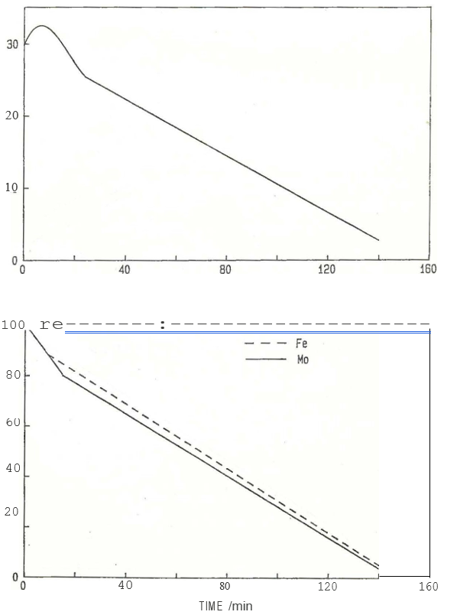

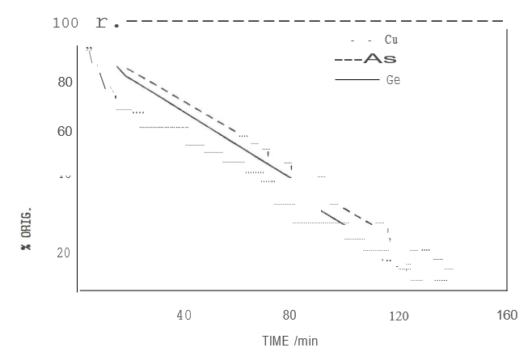

Fig.7 - Rate of chlorination of copper, arsenic, and germanium in the alloy

about 20 minutes. The initial increase in mass shown in Figure 5 can be explained if the chemical reaction in equation 2 is much faster than the formation of Fe2Cl6 (equation 3) and its diffusion from the reaction surface (equation 4). It was observed, in fact, that the volatilization of ferric chloride only commenced after an induction period of about 6 minutes, and this is consistent with the above theory, and explains the trend in Figure 5. After the induction period, these reactions come to a steady-state and maintain a constant thickness of the ferrous chloride layer at the surface. Although no rate expressions have been determined, the reaction of the sample, as a whole, appears to fit the shrinking solid particle model<7), which involves three successive steps:

Step 1: Diffusion of reactant A (in this case chlorine) from the main body of gas through the gas film to the surface of the solid (equation 1).

Step 2: Reaction on the surface between reactant A and solid (i.e. reactions (2) and (3).

Step 3: Diffusion of reaction products (the vaporized chlorides) from the surface of the solid through the gas film back into the main body of gas (equation 4). The reacting particle shrinks and finally disappears, as illustrated in Figure 9.

During the first ten to twenty minutes, the slopes of the curves are different for the various metals (Figures 6 and 7), after which they flatten off to a similar gradient. It appears that up until the time when the sample surface is completely covered by the FeC12 layer, the exposed metal particles react with the chlorine at different rates. As

predicted by thermodynamics, germanium apparently chlorinates the

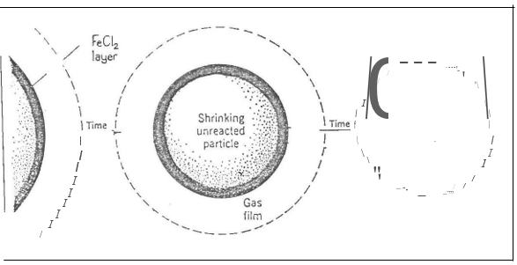

Fig.9 - Representation of the shrinking solid particle model

fastest in this stage of the reaction (Figure 7). However, the rate of reaction of the ferrous chloride surface layer, once formed, determines the rate of chlorination of all the metals.

Since the surface layer consists predominantly of FeC12, the rate of chlorination of all the elements is controlled by the rate of conversion.

of FeC12 to Fe2Cl6 (and this, in turn, is determined either by the rate of reaction 3, or by the rate of diffusion of chlorine or Fe2Cl6).

Although FeC12 is a solid in the temperature range used, the surface layer appeared to have been molten. This is probably due to local.

hot spots in the sample.

A decrease in chloripation rate occurs after 15-24 minutes, observable in Figures 5, 6, 7 and 8. Not enough evidence was obtained to explain this fact, although there are various possible reasons:

i) The most likely reason is the ease of chlorine diffusion through the surface layer of ferrous chloride (shown later to be the rate controlling step). Before the sample is completely covered, diffusion will be relatively fast. However, once the complete steady-state layer (which

appears to be relatively impenetrable) is formed, chlorine.

diffusion is more retarded. Hence the rates of training

of FeC12 and subsequently FeC13 are slower.

i.e. Two different rate-controlling steps may occur during the chlorination, one limiting the reaction before the surface layer is formed, and the other (diffusion) after the layer is formed.

ii) Although temperature has only a slight effect on the reaction rate (discussed in the next section), the initial temperature spike that results from the exothermicity of the reaction could be responsible for the faster reaction rate over the first 20 minutes.

iii) A less likely reason, but still a possibility, is the fact that the flowrate of chlorine, and therefore the chlorine partial pressure, progressively decreased during the course of each reaction.

|  |  |  |  |  |  |  |
| --- | --- | --- | --- | --- | --- | --- |
| Partial Pressure | 0.73 | 0.67 | 0.63 | 0.63 | 0.56 |  |
| Time | 0 | 15 | 24 | 60-t | 100-t | 140 minutes |

This could account for the decrease in chlorination rates, but the change does not seem large enough to have such a great effect on the rate.

**5.2.2 EFFECT OF TEMPERATURE**

The rate of chlorination of the alloy is only slightly dependent on the temperature. (Table I, (AT)C27-30, Appendix). By almost doubling the furnace temperature, the rate increased by only 12 per cent. This indicates that the slow step in the reaction is diffusion (either diffusion of chlorine through the FeC12 surface layer, or Fe2Cl6 away from the solid surface), and not chemical reaction (reactions 2 and 3).

**5.23 EFFECT OF SAMPLE QUANTITY AND PARTICLE SIZE**

Efficient chlorination of samples larger than 30 g was not achieved, for two reasons:

i) As the FeC12 layer coats the sample surface, the sample, which is arranged as a plug in the reaction tube, becomes obstructive. The gas flowrate therefore decreases, as back pressure develops. This becomes more severe the larger the sample.

ii) The FeC13, which condenses further down the tube can also cause a blockage if too much is formed, even though it is

fairly porous.

These two problems can be overcome by using larger apparatus.

Chlorinations of samples in the form of beads (5 mm diameter), powder and fine shavings were compared, and the results indicated that the rate is independent of sample particle size. This is an unexpected result as the rate of a heterogeneous reaction should be proportional to the area of the surface at which reaction takes place, and the surface area is, in turn, proportional to the particle size. The surface properties of the powder, beads and shavings were not characterized in this study, however, and it is possible that the total surface area was quite different from the superficial surface area.

**EFFECT OF GAS FLOWRATES (f ABLE I, APPENDIX: (AT)C26,31)**

There was no change in chlorination rate when the carrier gas flowrate was doubled while keeping the chlorine flow constant. This indicates that the rate of diffusion of the chlorinated products (i.e. Fe2CI6) away from the reaction zone into the bulk phase is not the rate determining step, as this step would be dependent on the carrier gas flowrate. However, the reaction rate increased with an increased chlorine partial pressure, and this is in agreement with the literature. On the basis of his result, it appears that the chlorination rate is controlled either by diffusion of chlorine or by the surface reaction of FeCI2 with chlorine.

Therefore, the one mechanism that seems to fit all the experimental evidence, is rate control by diffusion of chlorine from the gas phase through the surface layer of ferrous chloride to the surface of the unreacted iron core.

**5.3 Recovery of Germanium Tetrachloride**

It was found that an empty, ice-cooled trap used for trap 1 (Figure 3) was inefficient in condensing GeC14. The chloride was swept along in the gas stream, probably due to its fairly large vapour pressure (about 0,1 atm at room temperature). For this reason, two water traps were used so that the gas stream would bubble through the water with the GeC14 being dissolved. The type of germanium species in the water was not identified, although it is most likely present as "soluble" GeO2 (solubility 4 g/1 in cold water) <8.9). A method for recovering the Ge from solution was not investigated, but it is likely that either distillation or solvent extraction would be effective.

53.1 SATURATION LIMIT

The dissolution of GeC14 in water was investigated by repeating a one-hour chlorination four times and using the same solution in Trap 1 throughout. The saturation limit was not reached after 4 cycles, and the Ge concentration increased to 1240 ppm (Figure 10). This corresponds to 100 per cent recovery of germanium from 62,5 g of alloy 21 (which is twice the size of the largest sample used in this investigation). If, in fact, GeO2 is the product formed, then even more GeC14 could easily be dissolved in the solution. Thus, it appears that this method of trapping GeC14 could be developed for large scale work.

**53.2 WATER TRAP VARIATIONS**

A number of techniques for improving the efficiency of germanium recovery in Trap 1 were tested, and the results are given in Table 3.

The first four modifications were designed basically to decrease the bubble size so that greater GeC14 dissolution would occur. Modifications (1), (2) and (4) succeed in doing this, while (3) were, on the whole, worse. This was due to the frit causing back pressure. The high recovery by trap 2 in run (4) is possibly due to bubbles being carried over from trap 1. Run (5) was found to be the most efficient, but could create problems at greater depths, due to the larger pressure head of water. The bubbles have a greater residence time in the water and hence a greater chance of Ge_Cl4 dissolution. By increasing the length of time of the final purge, transport of almost all chlorinated Germanium into the traps is ensured (Run 6).

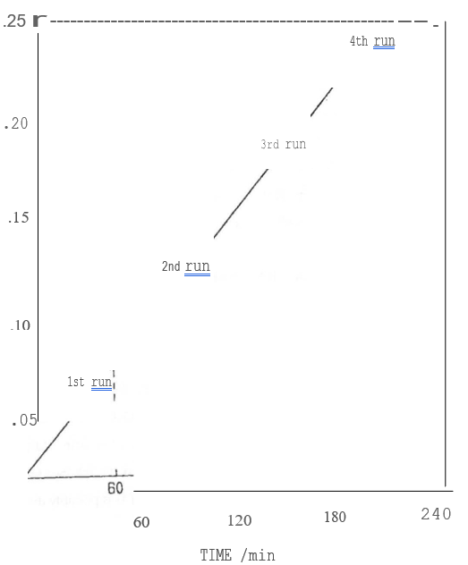

Fig. 10 - Repeated dissolution of GeO4 into water

**Table 3**

**Traps used for Recovering Germanium, and their Efficiencies.**

|  |  |  |  |
| --- | --- | --- | --- |
| Modification of Trap 1 | Recovery of chlorinated Ge/% | | |
| Trap 1 (200 ml) | Trap·2 (100 ml) | Total |
| Standard | 79.0 | 6.1 | 85.1 |
| 1. Stirred | 88.7 | 3.7 | 92.4 |
| 2. Stirred + ice-cooled | 84.9 | 3.0 | 87.9 |
| 3. Frit on inlet | 79.5 | 0.3 | 79.8 |
| 4. Surfactant | 85.5 | 9.0 | 94.5 |
| 5. Water de the doubled (21 .cm, 50 ml) | 93.2 | 5.8 | 99.0 |
| 6. Longer final purge | 90.1  (488 ppm) | 7.9 | 98.0 |

**CONTAMINANTS**

Arsenic is the major contaminant of the germanium solutions from the two traps (Table 4) and, here too, the identity of the arsenic species was not established in this investigation. The iron concentrations are less than 1 ppm and 0,3 ppm in traps 1 and 2, respectively, while about 12 ppm molybdenum is present in each. The arsenic concentration (as well as the Germanium) increased in trap 1 when the carrier gas flowrate was increased.

**Table 4**

**Arsenic Contamination of Traps**

|  |  |  |
| --- | --- | --- |
| Modification of trap 1 | Arsenic recovery/% and concentration (ppm) | |
| Trap 1 | Trap 2 |
| Standard Surfactant  Water depth doubled | 42 (1850 ppm)  52 (2350 ppm)  62 (2750 ppm) * | 29 (2500 ppm)  45 (4100 ppm)  29 (2500 ppm) |

* Ppm converted to value for 200 ml trap.

Since GeC14 and AsC13 have similar condensation temperatures, it appears that whatever technique traps GeC14 well will also improve the trapping of AsCl3. The two chlorides cannot be separated completely by fractional distillation. However, they can be separated by another method, using copper turningsC9).

**53.4 CIDDRIDE DISTRIBUTION THROUGH SYSTEM**

The system was divided into 6 regions (Figure 11) with analyses performed for the five major metals in the alloys. The chlorides condense along the tube according to the temperature gradient, but complete separation is not achieved. Regions occur that are dominated by a certain chloride, with small amounts of the other chlorides present (Table 5). From the thermodynamics molybdenum is expected to form MoCl5. However, the physical appearance of the condensed species resembles MoCl3.

**Table S**

**Distribution of Chlorides Along Reaction Tube**

|  |  |  |  |  |  |
| --- | --- | --- | --- | --- | --- |
| Region | % Original Metal | | | | |
| Fe | Ge | Cu | Mo | As |
| 1 | 13.3 | 7.4 | 13.8 | 11.0 | 10.7 |
| 2 | 0.1 | <0.3 | 24.4 | 0.0 | 0.2 |
| 3 | 2118 | 1.1 | 23.8 | 33.6 | 0.2 |
| 4 | 0.1 | <0.3 | 0.0 | fil12. | 0.1 |
| 5 | 0.0 | *m* | 0.0 | 0.3 |  |
| 6 | 0.0 | 8.3 | 0.0 | 0.4 | 40., l |
| Total | 104.3 | 96.6 | 62.0 | 106.2 | 97.2 |

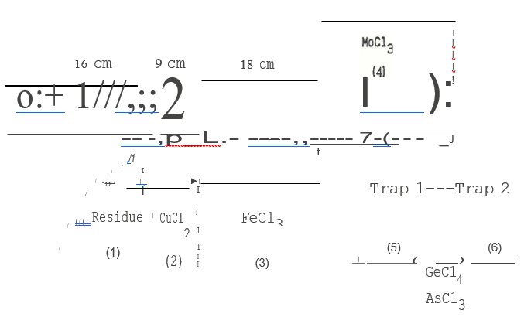

Fig. 11 - Dissolution of chlorides along reaction tube

Accurate results were not obtained for two reasons:

i) As mentioned before, errors in analyses probably occurred due to the very small quantities of material produced

ii) Removal of chlorides from the tube is difficult due to them being hygroscopic and present in small amounts.

**5.4 Chlorination of Tsumeb Slag Fume**

It was decided to investigate the chlorination of the fume R15 (supplied by L Simpson and K Samuel of Mintek, from their hydrometallurgical process) in an attempt to recover the Germanium. This work will form a section of its own, independent of the previous work.

The composition of the Tsumeb slag fume is shown in Table 6, the metals present as oxides, hydroxides and sulphates.

|  |  |  |  |  |  |  |  |  |  |  |
| --- | --- | --- | --- | --- | --- | --- | --- | --- | --- | --- |
| Metal | Zn | Pb | Fe | Ge | Cu | As | Mo | Ga | Cd | Si |
| %  (by mass) | 30,0 | 9,51 | 7,55 | 0,50 | 0,46 | 2,01 | 0,17 | 0,12 | 95pprr | 0,62 |

The apparatus and chlorination procedures were the same as for the previous work, except that a sample size of 20 g was used and the first trap contained 500 ml of water. Gas flowrates were the same as for (AT)C24.

**5.4.1 EFFECT OF TEMPERATURE**

Figure 12 shows that the chlorination is strongly dependent on temperature. It was also observed that no surface layer formed on the sample, and that the residues were found to contain virtually no chloride. This suggests that the rate of chlorination of the fume is not controlled by diffusion (as in the alloy) but by the chemical reaction of chlorine with the metal species.

The effect of temperature on the rates of chlorination of the individual metal species is shown in Figures 13 and 14. All the rates are strongly dependent on temperature, although there is not much effect on the chlorination of iron below 700°C. Although it is possible to chlorinate 90 per cent of the Germanium after 2 hours, it is not likely that this can be done selectively, since zinc, the major constituent of the fume, chlorinates more readily than all the other metals (except molybdenum).

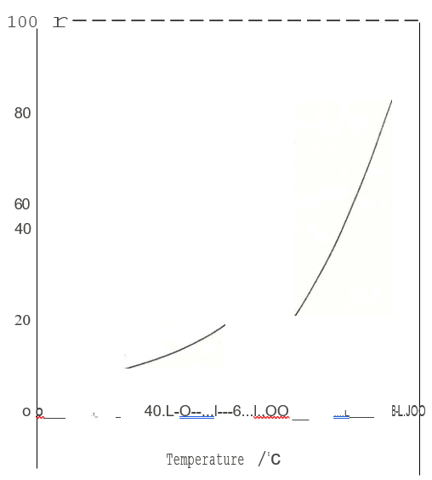

Fig. 12 - Effect of temperature on the chlorination of fume R15 (Time ==2 hrs)

**5.4.2 EFFECT OF TIME**

Figure 15 shows the change in mass of the fume at 800°C, which is rapid over the first 40 minutes and then tapers off. After about 2 hours there is only a small mass decrease. The individual chlorination rates are shown in Figures 16 and 17. Molybdenum, zinc and lead chlorinate completely within 80 minutes, while iron chlorinates the slowest.

**5.4.3 GeC14 RECOVERY AND CONTAMINANTS**

All the chlorinated Germanium was recovered in the water traps, with a small amount of contamination from Zn, Pb and Fe (each less than 20 ppm). Once again, the major contaminant was as (295 ppm). Most of the other chlorides condense before the first wool plug. A fine, yellow-white, powdery deposit occurs at about 14-30 cm from the sample, and was found to be mainly zinc and lead chlorides.

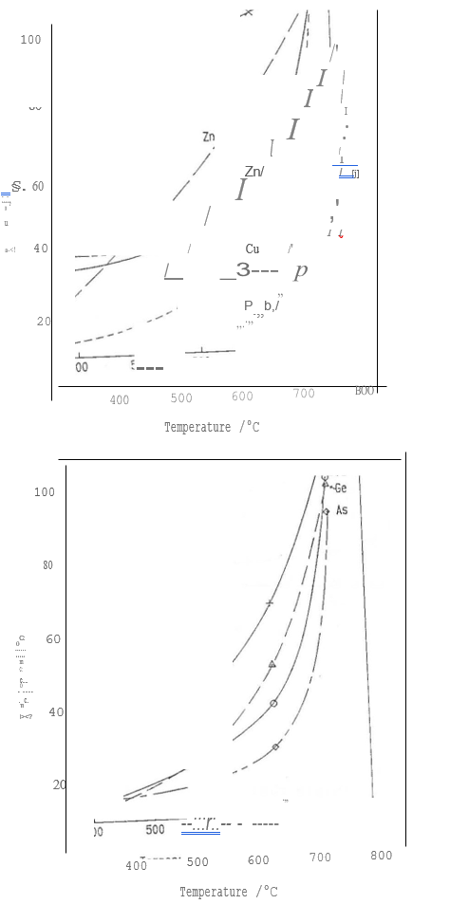

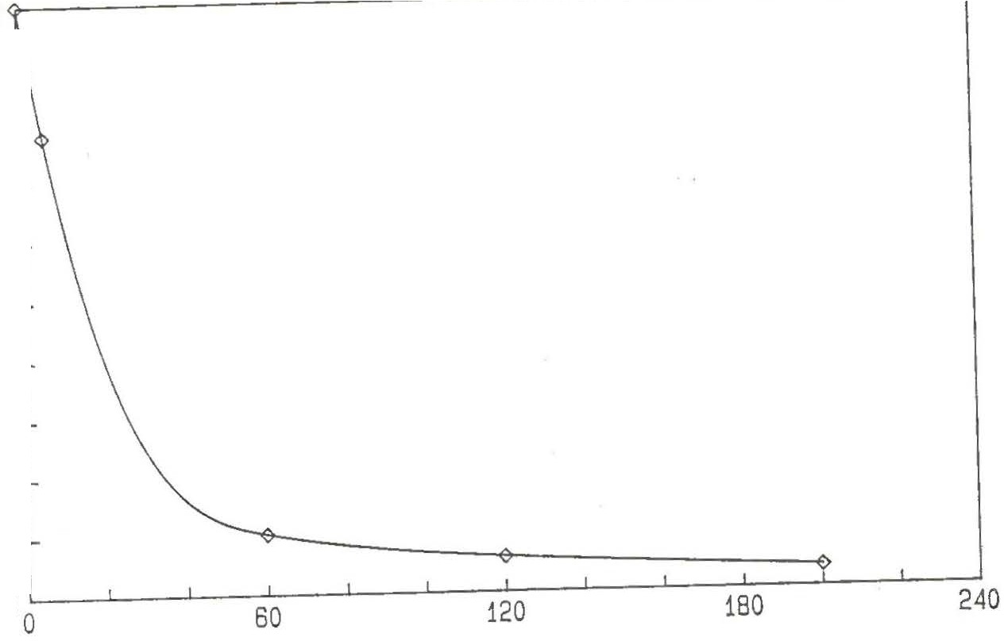

16

12

8

4

Figure.15. Sample mass change during chlorination of fume R15 at 800°C

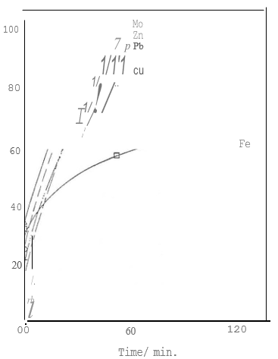

Figs 16 & 17 - Rate of chlorination of metal species in fumes at 800°C

**ROASTED FUME**

A sample of the fume was roasted prior to chlorination so that only oxides would be present. The effect of this can be seen in Figure 18. Roasting caused a small decrease in the chlorination rate of the zinc and lead species, but there was no observed effect on germanium, since during this time period no germanium chlorinated. The chlorination rate of iron was decreased considerably.

**6.CONCLUSIONS**

i)During the chlorination of alloy, a ferrous chloride layer that coats the alloy sample is formed, and the rate of reaction of the layer determines the chlorination rate of the other metals present. 90 per cent of the Germanium is chlorinated in about two hours. In the case of the fume, the surface layer does not form.

ii)The chlorination rate of alloy, and hence the FeC12 layer, is only slightly dependent on temperature, independent of carrier gas flowrate, but dependent on chlorine partial pressure. Toe rate is therefore probably controlled by diffusion of chlorine from the gas film to the heterogeneous reaction surface. The chlorination rate of fumes, however, is strongly dependent on temperature and is probably controlled by the chlorination reactions.

iii)Iron and germanium can be separated by ensuring the condensation of FeC13 behind a filter, with GeC14 being recovered furth.er along the reaction tube at a lower temperature. The recovery involves bubbling the gas stream through a volume of water, so that GeC14 is dissolved.

iv)The chlorination process has been shown to be technically feasible. However, because it is not possible to selectively chlorinate germanium, the process would only be economically feasible if chlorine could be recovered cheaply from the FeC13 that is produced.

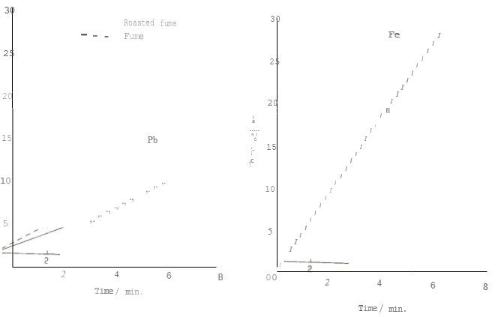

Fig. 18 - The effect of roasting the fume before chlorination.

**7. REFERENCES**

1. Z A Foroulis. Mechanism of chlorination of iron at elevated temperatures. From Metal-Slag-Gas Reactions and Processes 1975, 571-580.

2. Z A Foroulis. Kinetics and mechanism of the reaction of Iron-Chromium and Iron­ Chromium-Molybdenum alloys with chlorine gas. Metall. Trans A Vol 13, Jan 1982, 153-159.

3. R J Fruehan. Rate of chlorination of metals and oxides, Part 1. Metall Trans. Vol 3, Oct. 1972, 2585-2592.

4. M L Kumar et al. Kinetics and Modelling of the gas-phase chlorination of chalcopyrite. Canadian Metall. Quarterly Vol 26 No. 1, 1987, 29-36.

5. A Landsberg, F E Block. A study of the chlorination kinetics of germanium, silicon, iron, tungsten, colurnbium and tantalum. Report on investigations 6649, 1965, U.S Department of the Interior.

6. H R Hamer et al. Recovery of Germanium from scrap materials. Patent U.S 2, 767, 052, Oct 1956.

7. 0 Levenspiel. Chemical Reaction Engineering, 2nd Ed. pp 369.

8. E G Rochow. Germanium. Comprehensive Inorganic Chemistry Vol. 2, pp 27.

9. J A O'Connor. Germanium's Electronic Upsurge. Chemical Engineering April 1952, 158-160, 290.

**Appendix**

**TABLE I**

**Experimental Conditions**

|  |  |  |  |  |  |  |  |  |
| --- | --- | --- | --- | --- | --- | --- | --- | --- |
| Run | Sample | Mass  *lg* | Temp  *1°C* | Time  /min | Ar  /ml/min | Cl2  /ml/min | Cl2 excess | Residue mass/g |
| Cl,C3 | Fe Fe Fe Fe Fe  Alloy 7/E  ) Alloy 7/E  Ge  Ge+ Fe  Fe Fe  Fe beads Ge+ Fe  Ge+ Fe  Ge+ Fe | 10 | 400 | 30 | 150 | 250  250  250  250  250  250  350(10)*,  250  250  400(10),  300  120  400(12),  300  400(12),  300  400(8),  300  430000l 12,l.  250 36 ,  200 40,  150 20  430001121,  250 36',  200 20,  170 *2q<,*  150 (5) | 1,25 | - |
| C2 | 10 | 400 | 30 | 90 | 1,25 | - |
| C4 | 10 | 400 | 35 | 150 | 1,45 | - |
| *cs* | 30 | 400 | -  95 | 150 | 1,32 | 5,6 |
| C7 | 15 | 400 | 60 | 150 | 1,66 | 1,0 |
| (AT)C8 | 20 | 400 | 80 | 150 | 1,65 | 6,5 |
| (AT)Cl | 20 | 400 | 80 | 150 | 1,75 | 10,2 |
| Cll | **1** | 400 | 5 | 150 | 2,03 | 0 |
| C12 | 0,5 +  24,5 | 400 | 120 | 100 | 2,46 | 0,6 |
| C13 | *5* | 340 | 46 | 350 | 1,84 | 1,0 |
| C14 | 30 | 320 | 144 | 100 | 2,46 | 1,0 |
| C15 | 30 | 400 | 150 | 100 | 2,57 | 0,3 |
| C16 | 0,9 +  29,1 | 320 | 150 | 100 | 2,54 | 1,9 |
| C17 | 0,7 +  29,3 | 320 | 120 | 10800!640l,,  60 20 | 1,60 | 1,8 |
| C18 | 0,7 +  29,3 | 340 | 105 | 10800f640l,.  60 (5 | 1,42 | 3,6 |

*Number of minutes at particular flowrate

|  |  |  |  |  |  |  |  |  |  |  |  |  |  |  |  |  |  |  |  |  |  |  |  |  |  |  |  |  |  |  |  |  |  |  |  |  |  |  |  |  |  |  |  |  |  |  |  |  |  |  |  |  |  |  |  |  |  |  |  |  |  |  |  |  |  |  |  |  |  |  |  |  |  |  |  |  |  |  |  |  |  |  |  |  |  |  |  |  |  |  |  |  |  |  |  |  |  |  |  |  |  |  |  |  |  |
| --- | --- | --- | --- | --- | --- | --- | --- | --- | --- | --- | --- | --- | --- | --- | --- | --- | --- | --- | --- | --- | --- | --- | --- | --- | --- | --- | --- | --- | --- | --- | --- | --- | --- | --- | --- | --- | --- | --- | --- | --- | --- | --- | --- | --- | --- | --- | --- | --- | --- | --- | --- | --- | --- | --- | --- | --- | --- | --- | --- | --- | --- | --- | --- | --- | --- | --- | --- | --- | --- | --- | --- | --- | --- | --- | --- | --- | --- | --- | --- | --- | --- | --- | --- | --- | --- | --- | --- | --- | --- | --- | --- | --- | --- | --- | --- | --- | --- | --- | --- | --- | --- | --- | --- | --- | --- |
| |  |  |  |  |  |  |  |  |  | | --- | --- | --- | --- | --- | --- | --- | --- | --- | | Run | Sample | Mass  *lg* | Temp  ;oc | Time  /min | Ar  /ml/min | CI2  /ml/min | Cl2 excess | Residue mass/g | | (AT)C21 | Alloy 7/E  Alloy 21 (shavmgs)  Alloy 21 (shavmgs)  Alloy 21 (shavings)  Alloy 21  Alloy 21  Alloy 21  Alloy 21  Alloy 21  Alloy 21  Alloy 21 | 30 | 340 | 24  24  120  120  2  6  15  24  40  60  90  120  140  40  90  90  90  90  40 | As for  As for  1815!460,l.  60 20  150f60 ,  120 60  As for  150  As for As for As for As for | C17 C17  3400(1(95l.  25013,6  200 40,  150 20  As for (AT)C23  (AT)C24  400f15 ,  300 25  (AT)C24 (AT)C24 (AT)C24 (AT)C24 | - | 31,8 | | (AT)C2: | 30 | 340 | - | 32,5 | | (AT)C2: | 30 | 340 | 1,60 | 4,4 | | (AT)C2L | 30 | 340 | 1,60 | 4,5 | | (AT)C2: | 30 | 340 | - | 31,0  32,7 | |  |  |  |  | 29,9 | |  |  |  |  | 25,4 | |  |  |  |  | 21,9 | |  |  |  |  | 19,0 | |  |  |  |  | 11,8 | |  |  |  |  | 7,5 | |  |  |  |  | 2,2 | | (AT)C2( | 30 | 340 | - | 19,4 | | (AT)C2 | 30 | 540 | 1,3 | 9,0 | | (AT)C2E | 30 | 440 | 1,3 | 8,9 | | (AT)C2S | 30 | 400 | 1,3 | 13,2 | | (AT)C3( | 30 | 600 | 1,3 | 8,5 | | (AT)C31 | 30 | 340 | 310 | *As* for (AT)C24 | - | 21,8 | |

TABLE I (continued)

**DISTRIBUTION LIST**

Mr RD Beck Gold Fields SA Ltd

Mr. TV Owen

Mr. H A R Meiring Tsumeb Corporation Ltd

Mr. EH O Meyer

Dr R Haegele

Dr A M Edwards

Dr P R Jochens

Dr L J Dry

Mr. HE James

Dr R L Paul

Dr M J Nicol

Mr. R C Mallett

Dr NA Barcza

Mr. A F S Schoukens

Mr. L J Erasmus

Mr. H Lagendijk

Dr C A Fleming

Dr B R Green

Dr J S Preston

Dr P J Harris

Dr M J Dry

Mr. KM Samuel

Mr. L W Simpson

Mr. R G Fowles

MS AW Fowles

MS F Stander

Mr. D Bessinger

Mr. LR Nelson

Mr. B M Joja